**Assignment Subjective Questions**

1. Which are the top three variables in your model which contribute most towards the probability of a lead getting converted?

Ans.

The top 3 variables which contribute most towards the probability of lead getting

converted are:-

1. **Lead Origin_Lead Add Form**
2. **What is your current occupation_other**
3. **What is your current occupation_unknown**

1. What are the top 3 categorical/dummy variables in the model which should be focused the most on in order to increase the probability of lead conversion?

Ans.

The top 3 categorical/dummy variables in the model which should be focused the most

in order to increase the probability of lead conversion are :-

1. **Lead Origin_Lead Add Form**
2. **What is your current occupation_other**
3. **What is your current occupation_unknown**
4. X Education has a period of 2 months every year during which they hire some interns. The sales team, in particular, has around 10 interns allotted to them. So during this phase, they wish to make the lead conversion more aggressive. So they want almost all of the potential leads (i.e. the customers who have been predicted as 1 by the model) to be converted and hence, want to make phone calls to as much of such people as possible. Suggest a good strategy they should employ at this stage.

Ans.

We have calculated sensitivity, specificity of the model

Here Sensitivity is the ratio of total number of conversions correctly predicted to

the total number of actual conversions whereas Specificity is the ratio of total number

of non-conversions correctly predicted to the total number of actual non conversions

For our model, the below graph has shown how the Sensitivity and Specificity rating

changes with change in the threshold value.

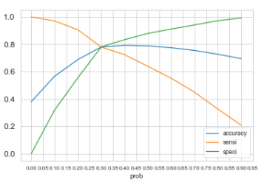

Here we can see that when the probability threshold is very low, the sensitivity is very

high and simultaneously Specificity is very low. Similarly for high threshold probability,

the Sensitivity is low and Specificity is high.

High Sensitivity implies that our model will correctly identify almost all leads which are

likely to convert. It will misclassify some non-converted leads as Converted i.e

overestimating the conversion likelihood

Since X Education has more manpower for these 2 months and they wish to make lead

conversion more aggressive and want to convert most leads, we can choose a lower

threshold value for Conversion Probability that means Sensitivity will be high implying

almost all the leads which are identified correctly will likely to convert and hence interns

can make more phone calls to more people which has the potential to get converted

1. Similarly, at times, the company reaches its target for a quarter before the deadline. During this time, the company wants the sales team to focus on some new work as well. So during this time, the company’s aim is to not make phone calls unless it’s extremely necessary, i.e. they want to minimize the rate of useless phone calls. Suggest a strategy they should employ at this stage.

Ans.

If the company reaches its target for a quarter and the company aim is to not make

unnecessary phone calls, we can follow the principle of High threshold value for

conversion probability.

This means Specificity rating is very high, means number of correct leads not getting

converted would be high. So the Sales team have to make less phone calls and can

focus on some new work